Wearables and AI: Pioneering Real-Time Health Surveillance and Predictive Diagnostics

Aditya Pichikala

Department of Computer Science and Engineering, Lovely Professional University, Phagwara, Punjab, India

**Abstract**

The integration of artificial intelligence (AI) into wearable health sensors has been showing a revolutionized chronic disease management by keeping continuous health monitoring and providing help timely predictions and recommendations. This study aims to explore the role of AI-enabled wearables in finding daily data and help to find to chronic disease symptoms early, with a focus on diabetes, cardiovascular diseases, and hypertension. This research aims to explore how using predictive analytics can impact patient outcomes and help reduce healthcare costs, providing an updated understanding of its effects. By the help of using wearable device using AI we can early detect the chronic diseases. It may cost low for analysing data and reminds us the early stage of disease.

Keywords: AI-Driven Wearable Sensors, Early Detection, Chronic Disease Management, Predictive Health Monitoring, Personalized Healthcare

**1.Introduction**

Experienced people and older people used to day “Health is Wealth” this might not get understand for the young people as they have so much anxiety about new things and want to earn money regardless of Food, Sleep, Health. The quotation “Health is Wealth” is found to be correct in the present times too. In this busy lifestyle of every person, increasing pollution and outbreak of pandemic and endemic diseases has led to poor and unhealthy lifestyle of human being, As per the recent studies, more than 90% of the population had been exposed to polluted environment. This industry revolution and population explosion has led to poor lifestyle of the majority of the population this became necessary to monitor and promote healthy lifestyle. Studies are conducted to put chronic diseases as the major cause of deaths globally, with WHO estimating that 71 percent of global deaths is attributed to chronic illnesses, and approximately 41 million deaths occur from diseases that could be controlled or prevented if diagnosed early enough (World Health Organization, 2023).

In this world using of internet of things (IoT), the internet of medical things (IoMT) plays a major role in Smart health Monitoring. (SHM) it works with the concept of interconnection of electronic devices on a network to allow data exchange. In past days these IoT are used to track simple metrics like step counter, heart rate, Newly developed sensors and AI algorithms have much more potential for wearable devices.

IoT and SHM are the internet of medical systems in hospitals by which the patients can be taken under the interpretation without any negligence nothing like traditional methods. Since ages, our technologies gives priorities towards life safety and to reduce inspectional costs. There are many types of methods such as SHM, General smart monitoring (GSM) are quite helpful in various ways, ultrasonic surface waves, ground penetrating radar techniques are few to name. IoT refers to a network of different electrical and wireless devices working together they all are interconnected and share the data of the patient In wireless communications there are so many various sensors and devices which can collect the patient data. SHM is one of he advancement in medical stream for monitoring conditions of the patients, specially comma patients are used to recognise their body movements by using IoT sensors. There are EYE blinker, Temperature measuring sensor devices for patients. There is rapid increase in patients and chronic patients in past few years who requires the remote-control health monitoring system. The applications of SHM are shown in fig1

According to the survey the mortality rate in the US rises day to day are 770,000 peoples are dies per year as per 2023. The main reason behind this is due to delayed treatment, usage of wrong medicine, inaccurate dosage etc. These SHM models help in this case and reduce the work flow of staff, doctors and medical professionals. Even some hospitals have started the use of smart beds which they recognize the actual condition of patients without any nurse. These beds are much good and effective for the comma and chronically ill patients to detects their movements, monitor, analyses and respond accordingly to their activities.

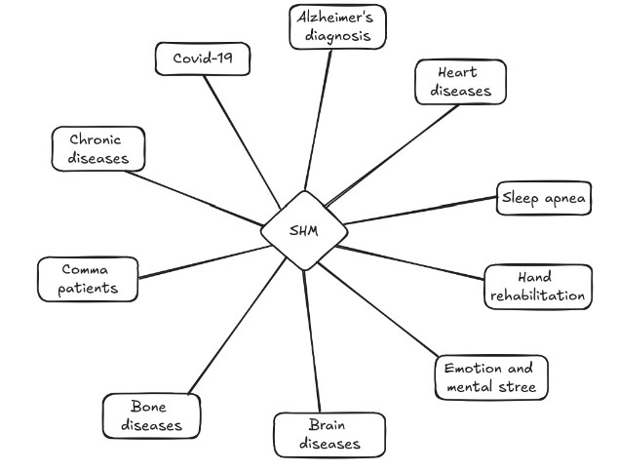

Fig. 1. Benefits and applications of SHM

IoMT plays an important role in creating healthy environment to get healthy life style and real time monitoring of general and special medical activities. SHM and IoT devices has proved its essentiality in the breakout of covid-19 pandemic like so many people those devices for checking oxygen, heartrate, blood pressure and other few. SHM has played a vital role in hospitals such as the ensuring doctors providing home treatment for covid patients. Patient and doctor exchange reports and medical prescriptions, by smartphones, laptops, tablets and few other ways over the wireless telecommunication network.

Medicines were ordered from rural and urban areas they are delivered by drones where the connectivity to rail or road is nearly impossible. SHM can able to monitor the real time condition of the patients from the remotely as the data of the patients is transformed in wireless communication. During covid everyone want to get online appointment of doctor to avoid going to hospitals in case there cannot direct contact with anyone. This work discusses about the new emerging technology that is SHM. The present work tells the details of various components of SHM and sub classes of SHM with role of deep learning and Artificial intelligence in handling the healthcare data generated in SHM

**2. Features of SHM and IoMT**

Smart health monitoring health devices has many significant features

1)Avoiding unnecessary visits of hospitals.

2)Doctors can remotely check condition of the patients in real time.

The data generated from these devices is safe from hackers. Healthcare is costly todays and these devices helps to solve this problem which is a great evolution in medical field and technology. By increasing the demands and belief of peoples on the smartness of devices and digitalization, the role of IoMTs and SHM will have to play a big role in the overall evolution and growth. SHM is a advanced technology in medical stream that can be used to Remotely controlled medical facilities to save the life of critical patients of heart attack, coma, asthma attack, diabetic patients etc. The data generated by SHM network and IoMT sensor devices need regressive analysis. These data analysis and computation data help to achieve multiple goals such as controlling the outbreak of certain diseases, predictive AI algorithm health monitoring, prevention of chronic diseases and fatality in patients. Deep learning and Artificial intelligence play a crucial role in analysis of health care data. Many frameworks and proposed architects are available in public domains for the analysis of healthcare computed data in SHM network.  
  
**3. Role of Artificial Intelligence (AI) and Deep Learning(DL) in SHM**

Deep Learning and transfer learning (TL) are subdivisions of machine learning (ML) in which the layers are used to collect effective data which progressively extract more and useful information from old data followed by its applications dealing with the data that have been effectively verified at every platform. Deep Learning provides useful information by collecting unseen data with the help of staked block of layers of the Deep Learning skeleton. Deep Learning models are used in wide range of applications in research area, SHM, etc. While the Transfer Learning is an part of learning machine that is applies by peoples when they have learned from previous situations, but Transfer Learning creates problems in studying the research for researchers and engineers. The relation of Deep Learning Machine Learning and Transfer Learning has been shown in the Fig. 2 clearly.

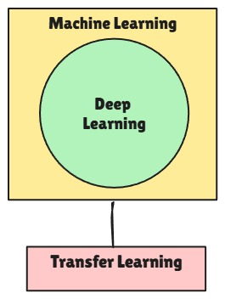

Fig.2. Relation of ML DL TL

There are so any advantages of using Deep Learning in SHM network. Deep Learning models gives the accurate and good information which is also helpful in collecting of bulk in data. Computational learning systems, doctors, SHM, and IoTs who have the ability to detect the real time condition of the patients and have the proper information about the patient data or prediction of future condition and anomalies of Alzheimer’s diseases generic diseases, diabetes, cancer, respiratory malady etc.

In mental health SHM is helpful to detect online mental conditions of patients by using certain apps example Happify, moodkit, wysa are to name of apps which are helpful in early detection of diseases like covid-19, Alzheimer’s diseases and other critical diseases. Deep Learning has been improved in other cases like data integration and data security etc. The uses of Artificial intelligence in machine learning algorithm and software in healthcare system the ultimate results of artificial intelligence is based on the data used in machine learning. The basic process of deep learning models is based on the neural network learning it is a type of artificial neural network (ANN) which is for visualization of images such as ultrasound, MRI CT scan Xray are few. With the help of deep learning the detection of generic diseases such as turner’s syndrome, sickle cell anemia, hemophilia, and the doctors are able to find the treatments for the future as well as future medication. The deep learning and machine learning are able to find the normal as well as abnormal data of the patients, by which the doctors can detect the disease and condition of patients.

Advancement in Internet of medical things hardware and software, use of GPU for training deep neural network and less time exploitation. Deep Learning crucial information of many critical patients specially coma sufferers by using multiple GSM, IoT and SHM modules. Deep Learning is also used for analysis of medical data obtained from wearable devices and medical devices such as smart watches, blood pressure monitoring devices, temperature and eye blinker, pulse oximeter, computed tomography (CT) scan, X-Ray images, Magnetic Image Resonance (MRI) ultrasound images, and so on. The main motive and purpose of monitoring real time health data is to prevent chronic diseases, trauma cases, prevention of disease outbreak in certain countries as well as maintaining healthy lifestyle. In recent study has shown that Deep Learning based framework was able to take the real time data of comma patient. The IoMT and medical equipment are the one of wireless communication with which the patients unlike the traditional methods saves power, less effect to staff, and time-consuming methods.

**4. Structural of SHM and IoMT**

These can be divided into several subparts on the basis of different parameters such as;

1. On the basis of transfer of health-related data or information from phone to phone i.e. from patients to the doctors.

2. Subscriber

3. Broker

4. Publisher

Publishers arrangement of connected sensors and patients record blood sugar level, Eco elegance, blood pressure etc. The center is able to store the data in clouds and center receives the data or information from publisher. The last is subscriber which are used for monitoring data and extracted from publisher which can be recognize by the smart gadget like tablets, wearable devices, like android smartphones, laptops etc. The classification of IoMT is presented in the Fig. 3. SHM on the basis of ranges single can be classified into the following sub categories

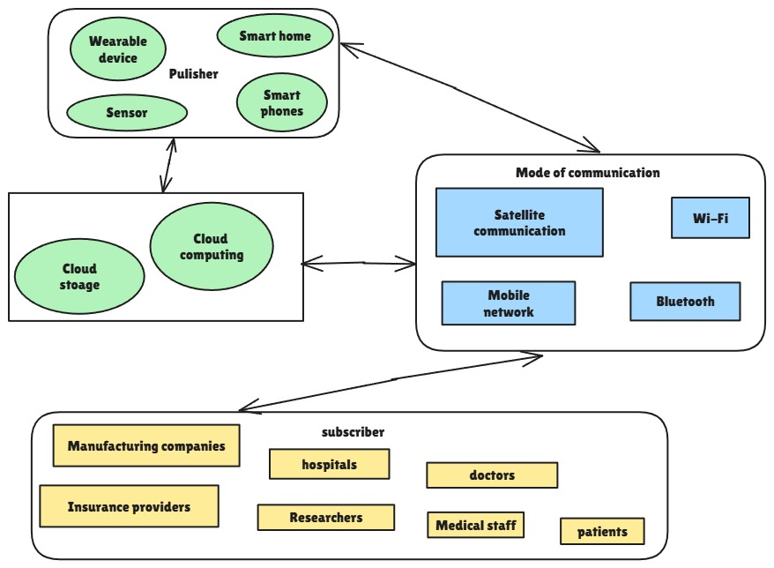

Fig.3. Components of IoT based networks

• RHMS (remote health monitoring system)

• MHMS (mobile health monitoring system)

• WHMS (wearable health monitoring system)

• GHMS (general health monitoring system

The properties of SHM has been shown in the Fig. 4. The RHMS the system can be able to send the data to or send from the location, covers the variety of symptoms that can be utilized in home and hospitals. The MHMS involves laptops, mobile phones, smartphones which are used as the main processing station. Whereas the wearable devices like digital watches, digital bracelets eye blinker, oximeter, pulse tracker etc, collect the data and relevant information regarding the type of sensors used in that By storing and visualize the real time data. These are advanced technology in the medical field in last years. GHMS monitor also plays important role in the modern days. This lowers the visits to hospitals for normal diseases of people. Now in these days people are much known about their health and can get treatment for their problems by using online medical services. They can find the relevant hospitals information on internet. For general the required components of medical IoTs are

1. Data acquisition

2. Communication gateway

3. Server

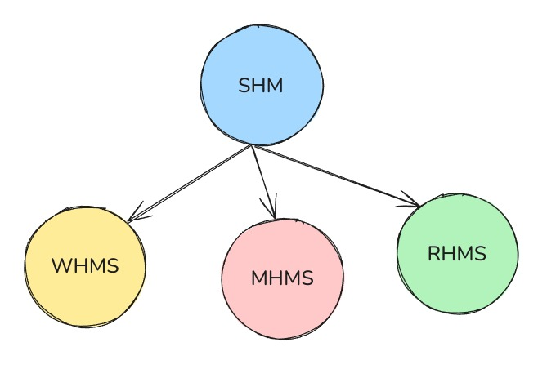

Fig.4. Sub class of SHM

Smart Health Monitoring (SHM) systems and various Internet of Things (IoT) devices are becoming widely used to track chronic diseases like Parkinson's, Alzheimer's, and dementia. Dementia is particularly common, affecting around 25 million people globally. Its symptoms often include memory loss, difficulty with problem-solving and decision-making, as well as depression and anxiety. While the exact causes of dementia are not fully understood, it is often linked to conditions like Alzheimer's and Parkinson's. SHM systems are making significant strides in managing these diseases, marking a major advance in healthcare. However, one of the major challenges is that the data collected by these systems could be misused by individuals or organizations for their own benefit, raising serious concerns about data security. This is an ongoing issue for researchers working on these technologies.

**5. Data security in SHM**

The data generated by Smart Health Monitoring (SHM) networks and Internet of Medical Things (IoMT) devices is often referred to as big data or health data. Managing this data requires significant computing power and storage space. Cloud computing and storage solutions help address these challenges, but since much of the data is sensitive and confidential, protecting it is crucial. Data security and privacy are key issues for SHM systems. Preventing misuse of this sensitive information by individuals or organizations for personal gain is essential. Ensuring data security involves physical security, authentication, and securing networks, computers, and storage. Techniques like cryptography, encryption, and genetic algorithms are widely used to protect data. Many security frameworks rely on third-party services, which raises trust concerns. Recently, technologies like blockchain and the Interplanetary File System (IPFS) have gained attention for their ability to securely exchange data, particularly in the finance and banking sectors.

Blockchain stores data in blocks, which are linked together in a chain. Each block contains several transactions, and when a new block is added, it includes the entire transaction history. The security of blockchain comes from cryptography, as each block is validated using cryptographic methods, along with timestamps and the hash value of the previous block, making it a highly secure way to transfer data. Blockchain has already been successfully applied in industries like logistics, manufacturing, management, and healthcare. There are various public frameworks that have shown success in healthcare services and SHM networks.

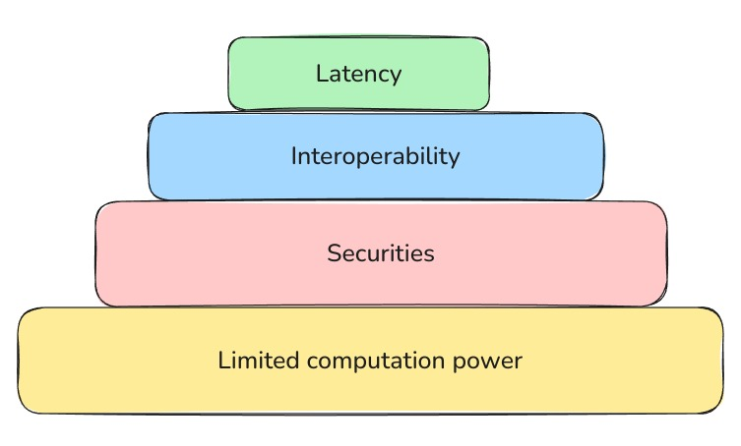

Fig.5. challenges in SHM

**6. Limitations of SHM and IoMT**

There are some limitations with Smart Health Monitoring (SHM) systems and medical IoT devices. One issue is that the different types of sensors collect various forms of data, which can sometimes contain errors and make it difficult to interpret or diagnose a patient's condition accurately. Additionally, wearable sensors can be uncomfortable, especially for children, so wireless sensors are often preferred. Another concern is the security of patient data, which can be vulnerable to hacking. Fraud is also a potential problem when using IoT healthcare systems.

S mart medical systems tend to be more beneficial for people with chronic conditions rather than for general healthcare purposes. However, IoMT devices rely on batteries or constant power, which may not always be available in remote areas. The major challenges with these systems are outlined in Figure 5.

Real-time monitoring requires fast and reliable network connections, which can be difficult to maintain in low-powered devices or in remote locations. Even though these limitations exist, they are not insurmountable and can be addressed with advancements in technology over time.

**7. Conclusion and future scope**

Smart Health Monitoring (SHM) systems have proven to be more effective compared to traditional health monitoring, which often results in delayed services, slower medication response, and a lack of timely precautions. With the integration of cloud computing and blockchain, SHM systems have gained the trust of both healthcare professionals and patients by improving data security and privacy. SHM is particularly effective for addressing the unique needs of critically ill patients, while also offering general health monitoring to help people meet personalized health goals and maintain healthier lifestyles.

Although SHM has been widely used in healthcare, its application in sports and general wellness is still limited and has potential for further exploration as technology evolves. SHM offers many opportunities for the future of healthcare, making things possible that were previously out of reach. This work reviews smart health monitoring systems that have successfully used deep learning and machine learning techniques to achieve better results. Similar reviews have often overlooked the role of machine learning and deep learning in SHM systems. The use of IoMT in SHM has also improved the speed and responsiveness of remote, real-time healthcare services.

**References**

**1] M. Tabaa, F. Monteiro, H. Bensag, A. Dandache, Green industrial Internet of things from a smart industry perspectives, Energy Rep. 6 (2020) 430–446,** [**https://doi.org/10.1016/j.egyr.2020.09.022**](https://doi.org/10.1016/j.egyr.2020.09.022)

**2] K. Haricha, A. Khiat, Y. Issaoui, A. Bahnasse, H. Ouajji, Towards smart manufacturing: implementation and benefits, Proc. Comput. Sci. 177 (2020) 639–644,** [**https://doi.org/10.1016/j.procs.2020.10.091**](https://doi.org/10.1016/j.procs.2020.10.091)

**3] J.M. Portnoy, A. Pandya, M. Waller, T. Elliott, Telemedicine and emerging technologies for health care in allergy/immunology, J. Allergy Clin. Immunol. 145 (2020) 445–454**

**4] M.M. Baig, H. Gholamhosseini, Smart health monitoring systems: an overview of design and modeling, J. Med. Syst. 37 (2013), https://doi.org/10.1007/ s10916-012-9898-z**

**5] A. Rahaman, M.M. Islam, M.R. Islam, M.S. Sadi, S. Nooruddin, Developing IoT based smart health monitoring systems: a review, Rev. Intell. Artif. 33 (2019) 435–440**

**6] M. Azimi, A.D. Eslamlou, G. Pekcan, Data-driven structural health monitoring and damage detection through deep learning: state-ofthe- art review, https:// doi.org/10.3390/s20102778, 2020**

**7] H.-J. Jang, K.-O. Cho, Applications of deep learning for the analysis of medical data, Arch. Pharm. Res. 42 (2019) 492–504**

**8] L. Yue, D. Tian, W. Chen, X. Han, M. Yin, Deep learning for heterogeneous medical data analysis, World Wide Web 23 (2020) 2715–2737**

**9] D. Ravì, C. Wong, F. Deligianni, M. Berthelot, J. Andreu-Perez, B. Lo, G.-Z. Yang, Deep learning for health informatics, IEEE J. Biomed. Health Inform. 21 (2016) 4–21**

**10] P. Ratta, A. Kaur, S. Sharma, M. Shabaz, G. Dhiman, Application of blockchain and Internet of things in healthcare and medical sector: applications, challenges, and future perspectives, J. Food Qual. 2021 (2021) 7608296, https:// doi.org/10.1155/2021/760829**